4CS015
Fundamentals of Computing

Lab Report

Name: Sagar Mishra
Group: 4
Student ID: np02cs4a250038

Module Leader Tutor
_______________ ______________
Table of Contents
Lab | Lab Title | Page No. | Tutor’s Signature
3 | 1. Part 1 3  a. Define half adder. 3  b. Draw a truth table for the sum and carry of the half adder. 3  c. Write the SOP expression from the truth table. 3  d. Draw the circuit using LogSim. 3  2. Part 2 4  a. Draw the truth table for the outputs of the full adder. 4  b. Write the corresponding sop expression for sum and carry of full adder and simplify the expression. 4  c. Draw full adder using two half adders and an OR gate. 5  3. Part 1 6  a. Using the three stages of design, construct the circuits for the following input /output values. Here A, B, and C are the inputs, whereas D, E, F, G, H, and I are outputs. Note: Draw circuit diagram using Logisim, corresponding to the simplified expression of outputs D, E, F, G, H, and I. 6

Name / Sign of Module Leader Name / Sign of Module Leader

_________________ ___________________
Date: Date:

Part 1

Define half adder.

- Half adder is a digital logical circuit that accepts two binary numbers of single bit and returns two output sum and carry.

Draw a truth table for the sum and carry of the half adder.

- Truth table:
Input A | Input B | S (Sum) | C (Carry)
0 | 0 | 0 | 0
0 | 1 | 1 | 0
1 | 0 | 1 | 0
1 | 1 | 0 | 1

Write the SOP expression from the truth table.

- Sum: S=A’B + AB’
- Carry: C=AB

Draw the circuit using LogSim.

- Circuit:
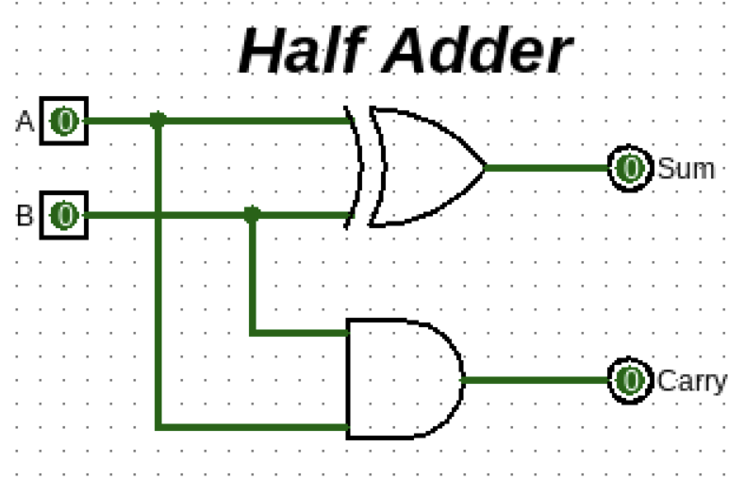

Part 2

- Draw the truth table for the outputs of the full adder.

- Truth table:
Input A | Input B | Carry IN | Sum | Carry OUT
0 | 0 | 0 | 0 | 0
1 | 0 | 0 | 1 | 0
0 | 1 | 0 | 1 | 0
1 | 1 | 0 | 0 | 1
0 | 0 | 1 | 1 | 0
1 | 0 | 1 | 0 | 1
0 | 1 | 1 | 0 | 1
1 | 1 | 1 | 1 | 1

- Write the corresponding sop expression for sum and carry of full adder and simplify the expression.

- SOP expression:
Sum (S)
= A.B’.C_{in}’ + A’.B.C_{in}’ + A’.B’.C_{in} + A.B.C_{in}

= (A ⊕ B) ⊕ C_{in}
Carry_{out} (C_{out})
= A.B.C_{in}’ + A.B’.C_{in} + A’.B.C_{in} + A.B.C_{in}

= AB + AC_{in} + BC_{in}

- Draw full adder using two half adders and an OR gate.

- Circuit:

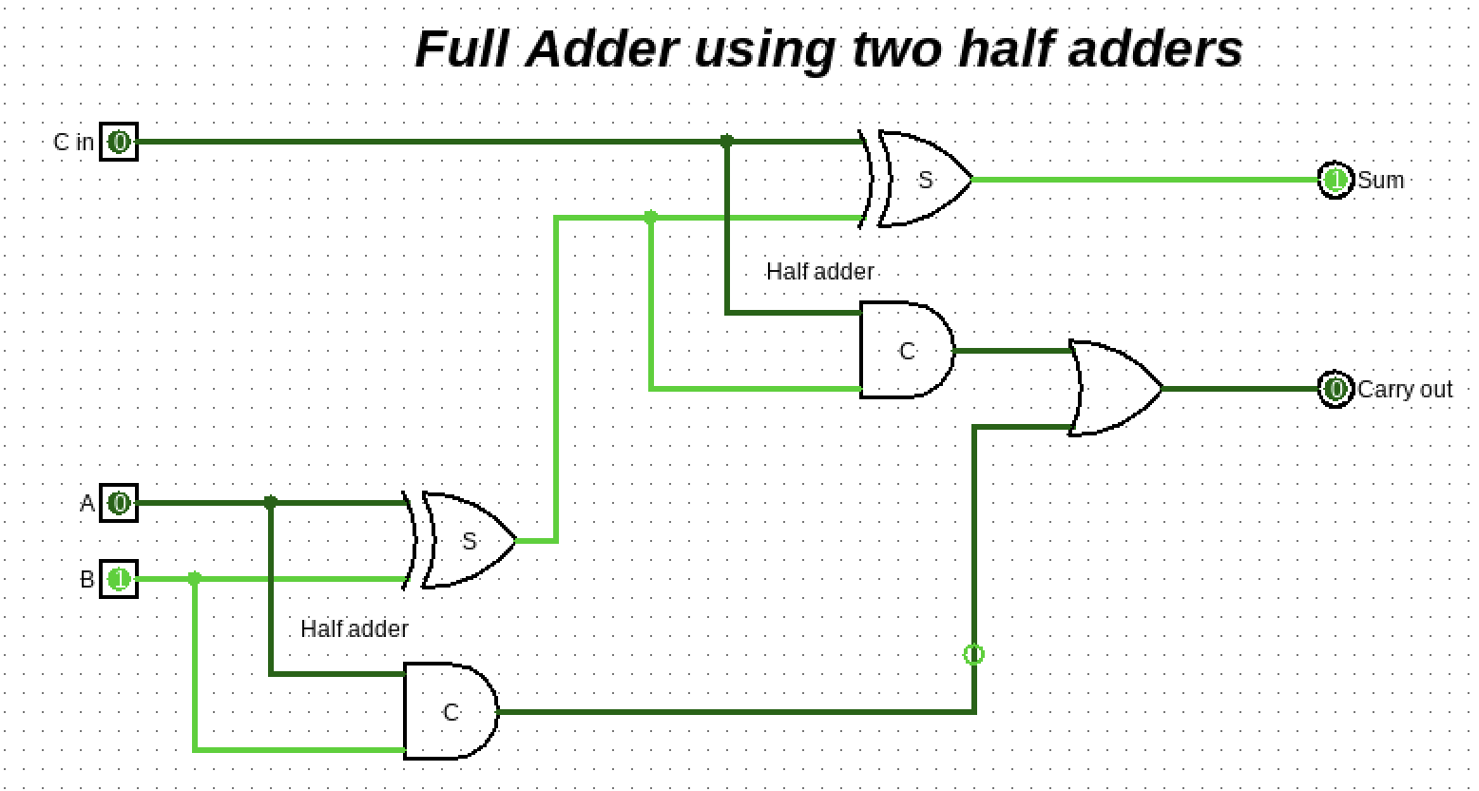

Part 1
- Using the three stages of design, construct the circuits for the following input /output values. Here A, B, and C are the inputs, whereas D, E, F, G, H, and I are outputs. Note: Draw circuit diagram using Logisim, corresponding to the simplified expression of outputs D, E, F, G, H, and I.

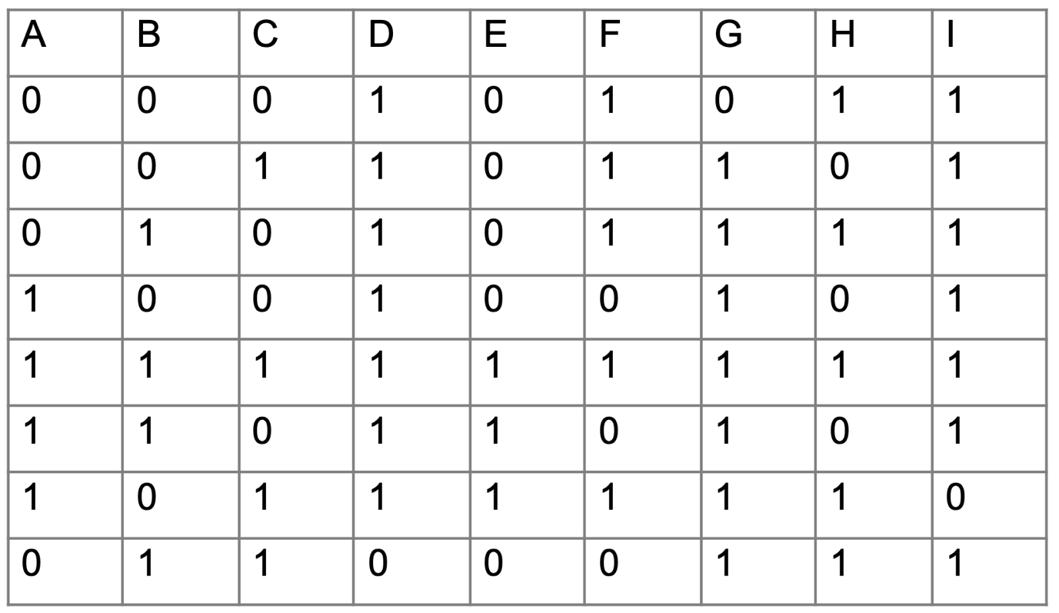
- Boolean expressions:

D = A + B + C’

E = ABC + ABC’ + AB’C = AB + AC

F = (A’ + B + C). (A’ + B’ + C). (A + B’ + C’)
= (A + B). (A + C). (A’ + C’)
G = A + B + C
H = (A + B + C’). (A’ + B + C). (A’ + B’ + C)
= (A + C). (A + B’). (A’ + C’)
I = A’ + B + C’

- Circuits:
D circuit
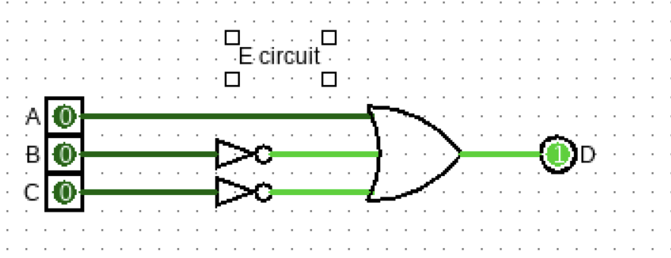
E circuit
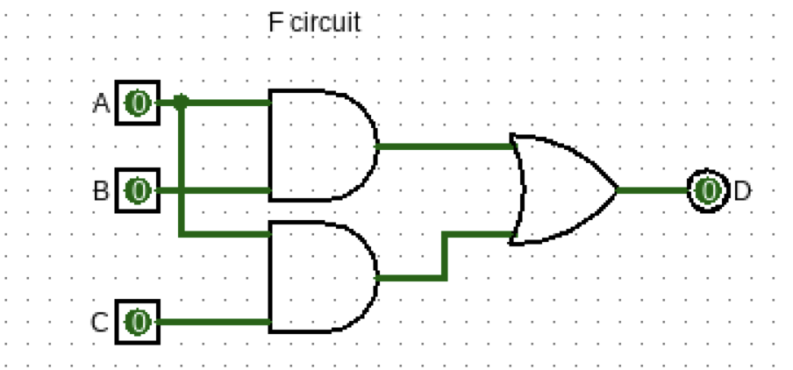
F Circuit
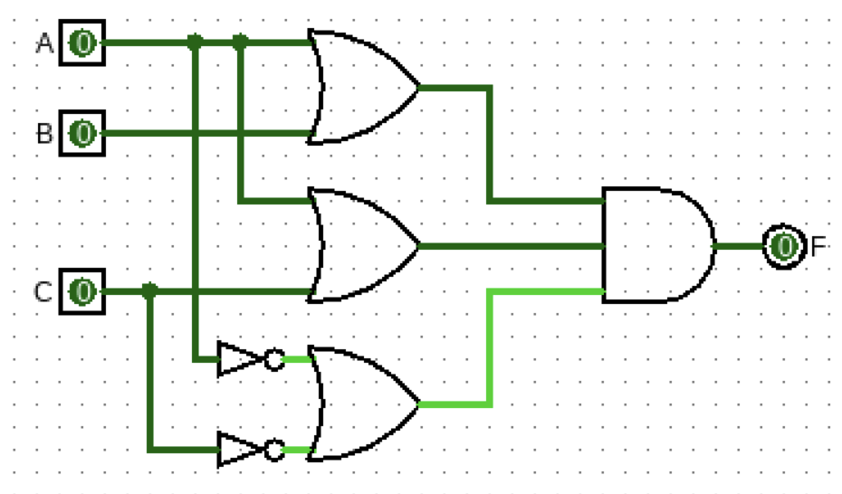
G circuit
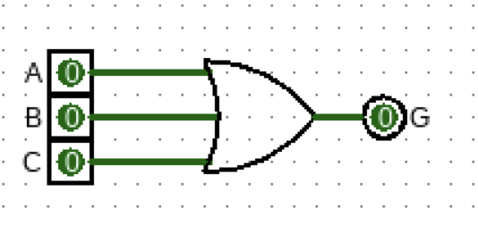
H circuit
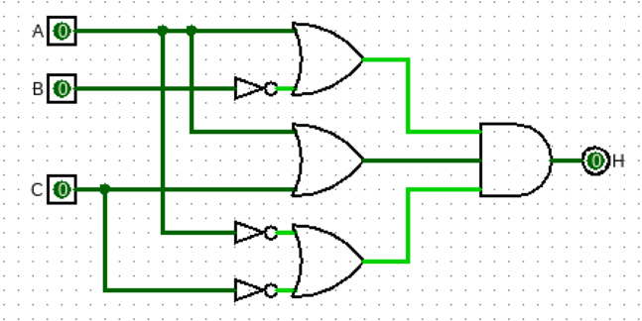
I Circuit
